10 years of signotec: A success story from Ratingen, Germany

With 10 years of history behind the company, signotec is poised to
move into the fast lane with its e-signature solutions

Within the first ten years since its inception, signotec GmbH has become a market and technology leading company in the development and manufacture of signature pads and accompanying software. For company founders Arne Brandes, Gunther Hagner and Wolfgang Specht, ongoing development is essential and also will play a significant role in the company’s future and its continued success. By adapting to newly available technologies and changing customer needs, the company has remained innovative and flexible, taking first place in the market with this approach.

Ratingen, Germany, April 2011; signotec GmbH celebrates its 10th anniversary this year. Displaying commitment, expertise and customer proximity, this young, innovative company has risen to the top of the sector of electronic signing via pen pad and tablet PC within an exceptionally short time. The products from signotec not only allow both handwritten and digital signing but also enable users to optimise their business processes, avoid media conversions, authenticate people and create legally binding documents. Electronic documents signed in this manner can be checked at any time, anywhere and by anyone without incurring any technical costs. Solutions from signotec keep the recording of signatures as simple as ever. Signatures are recorded directly in the electronic document. This eliminates the cost-intensive media conversions that arise when using paper. The electronic documents are protected by the digital signature and can therefore be verified as genuine.

“When we founded the company, we were entering new territory. At the time, we were exclusively developing software for signature verification systems in banks and were new to the industry. For this reason, our first step was to analyse customer demands and then to fulfil them as quickly as possible,” explains Brandes, one of the three managing directors of signotec GmbH. At the time, the signing software was being developed in Ratingen, but the sign pads were only being sold by the American pad manufacturer Topaz Systems. Eight years later, the decision was taken at signotec to manufacture its own signature pads in Germany alongside the proprietary software. “Our goal was to be the first and only company to market one-stop, integrated and complete solutions for an even wider range of companies and industries,” recalls Hagner. “But above all, we wanted to address our customers’ needs more precisely and provide special solutions. We placed particular emphasis on achieving the optimal price-performance ratio.” With this forward-thinking decision, signotec GmbH sprinted to the head of the pack of international providers. “This was clearly the right path: We have achieved a unique position for ourselves by developing and manufacturing our own solutions in Germany. The signotec pads set themselves apart from the competition with their ergonomic shapes, technical details and unbeatable software. Our Sigma and Omega models are ideally suited to both desk-bound and mobile use. As an additional special touch, the pads can be designed in different colours and customised with company logos,” says Hagner.

The company demonstrates a strong commitment to customer service, ensuring coverage across Germany with offices in Rodewald, Erfurt and of course at its headquarters in Ratingen. signotec solutions GmbH was founded in January 2010 against a backdrop of steadily growing international demand. The subsidiary, based in Spielfeld (near Graz) in Austria, is run by Jörg Prinzhorn and supports customers in Southern and Eastern Europe. signotec GmbH receives additional support from qualified sales partners located around the world. Despite economic crises and widespread recession, the company in Ratingen has seen steady positive growth from the outset, achieving ever-increasing results without losing perspective. With its signature solutions, the company has a healthy outlook and has increased turnover by more than 100% in recent years alone. “Word got around in many industries about the quality of our products, our tailor-made solutions and excellent service, and this is how signotec GmbH managed to achieve above-average growth. Of course, it also helped that we consider ourselves to be a partner to companies. We are there not only to carry out projects but also to support them from a holistic perspective.”

In the future, the managing directors hope to achieve further growth in various sectors. “The number of companies that generate cost-saving potentials through paperless processes will continue to rise. In particular, interconnected business and corporate relations across the world will bring about further change on the market. This is precisely what we consider to be both a challenge and an opportunity,” says Arne Brandes. “In future, companies will increasingly demand the advantages offered by our products, and these advantages can be accurately measured with our products.”

signotec’s clients include German and international industry customers, retail chains and companies, financial services providers, administrative offices, the healthcare sector, numerous savings banks and credit unions in Germany, as well as insurance companies and brokers. Among signotec’s customers today are well-known companies such as Knauf Gips AG, Vodafone, Siemens, BASF, Krombacher, Veltins, Miele, Lego and the Metro Group. Its successes in the various industries prove that signotec is capable of delivering complex, integrated solutions at a high level in terms of quality and quantity, from individually programmed software to coloured pad design carrying the corporate identities of companies.

“Looking ahead, we know that, above all, the market demands functionality, the best service and good prices, all without having to sacrifice quality. We are always in the process of learning and undergoing continual improvement and development. Our goal is expand our customer base, product offering and international activities and to further our growth. As part of this process, we rely on our dedicated and motivated team of employees. With our efficient and extremely reliable service, we provide highly developed technological products under what we consider to be the best conditions in the industry,” says Brandes

About signotec:
signotec was founded in 2000 and is the market and technology leader in the electronic signature sector using pen pads or tablet PCs. The products from signotec allow not only both handwritten and digital signing but also enable users to optimise their business processes, avoid media conversions, authenticate people and create legally binding documents. Electronic documents signed in this manner can be checked at anytime, anywhere and by anyone without incurring any technical costs. Solutions from signotec keep the recording of signatures as simple and secure as ever. Signatures are recorded directly in the electronic document. This eliminates the cost-intensive media conversions that arise when using paper. The electronic documents are protected by the digital signature and can therefore be verified as genuine. signotec’s clients include German and international industry customers, retail chains and companies, financial services providers, numerous savings banks and credit unions in Germany, as well as insurance companies and brokers. The subsidiary is based in Spielfeld (near Graz) in Austria and supports customers in Southern and Eastern Europe.

The three managing directors of signotec GmbH:
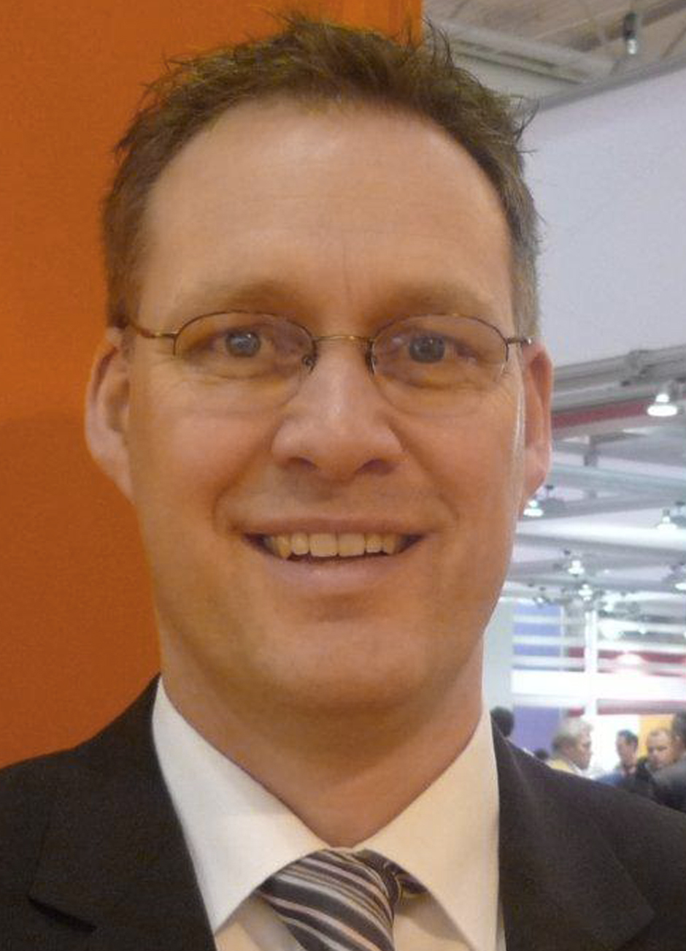
Arne Brandes

Gunther Hagner
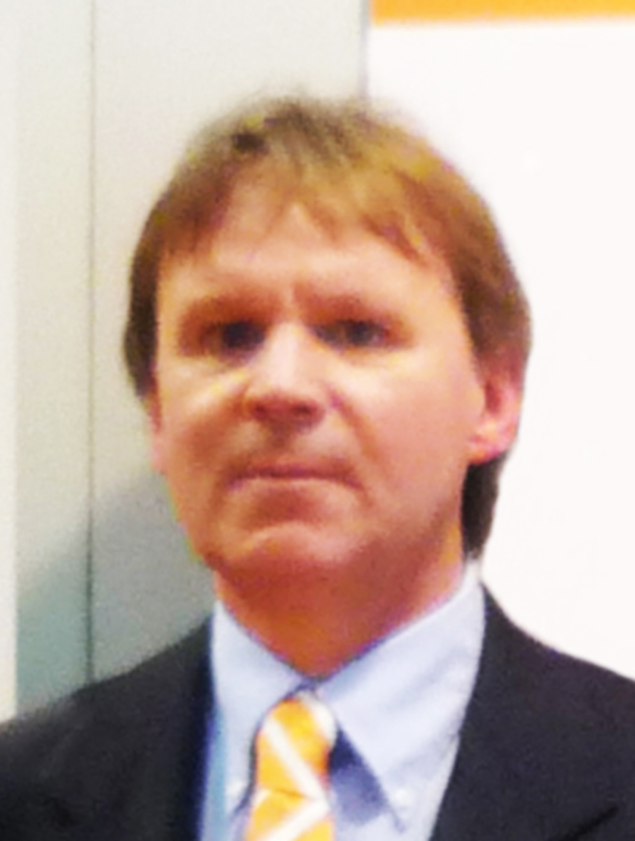
Wolfgang Specht

Contact for editorial offices:
signotec GmbH
Silke Langer
Neudorf 7
D-31637 Rodewald
Tel: 0 50 74 – 96 11 54
Fax: 0 50 74 – 96 11 56
Email: silke.langer@signotec.de
Contact for specialist queries:
signotec GmbH
Arne Brandes
Neudorf 7
D-31637 Rodewald
Tel.: 0 50 74 – 96 70 15
Fax: 0 50 74 – 96 11 56
Email: arne.brandes@signotec.de

